**WEEK-5**

**EMPLOYEE DATABASE**

**To do list:**

1. **Using schema diagram, create tables by properly specifying the primary keys and the foreign keys.**

create database employee;

use employee;

create table Project

(pno int,

Ploc varchar(20),

Pname varchar(20),

primary key(pno));

create table Dept

(deptno int,

dnamevarchar(15),

dlocvarchar(20),

primary key(deptno));

create table Employee

(empno int,

enamevarchar(10),

mgr_no int,

hiredate date,

sal int,

deptno int,

primary key(empno,deptno),

foreign key(deptno) references Dept(deptno));

create table Assigned_to

(empno int,

pno int,

job_role varchar(20),

primary key(empno,pno),

foreign key(empno) references Employee(empno),

foreign key(pno) references Project(pno));

create table Incentives

(empno int,

incentive_date date,

incentive_amount int,

primary key(empno),

foreign key(empno) references Employee(empno));

1. **Enter greater than five tuples for each table.**

insert into Project values(1,'Bengaluru','Small_Steel'),(2,'Chennai','Silly_Jazz'),(3,'Hyderabad','Othello'),(4,'Mysuru','Hornets'),(5,'Delhi','Moonshot'),(6,'Mumbai','Masque'),(7,'Kolkata','Malibu');

insert into Dept values(1,'HR','Bengaluru'),(2,'IT','Mysuru'),(3,'AccFin','Mumbai'),(4,'Production','Kolkata'),(5,'R&D','Delhi'),(6,'Marketing','Hyderabad');

insert into Employee values(1,'Dinesh',2,'2008-02-11',100000,3),(2,'Ramesh',4,'2009-01-12',150000,4),(3,'Suresh',5,'2010-10-09',250000,2),(4,'Rahul',6,'2004-02-19',500000,1),(5,'Nikil',1,'2005-04-12',50000,6),(6,'Mohan',9,'2012-05-14',80000,5);

insert into Assigned_to values(1,6,'System-analyst'),(2,3,'Software_architect'),(3,2,'Project_manager'),(4,5,'Team_leader'),(5,4,'Planner'),(6,1,'Software_engineer');

insert into Incentives values(1,'2009-01-12',40000),(2,'2012-02-19',35000),(3,'2015-10-12',50000),(4,'2004-10-20',100000);

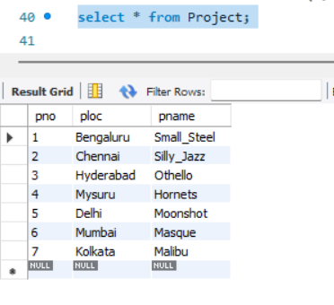

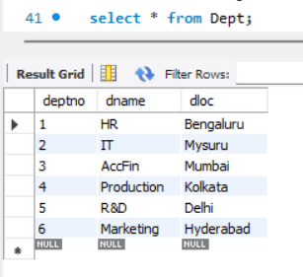

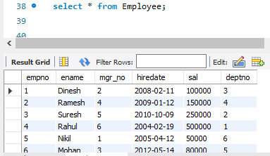

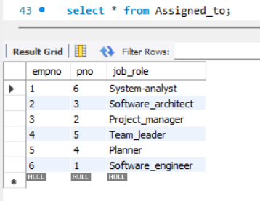

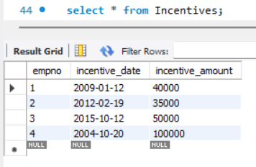

1. **Retrieve the employee numbers of all employees who work on project located in Bengaluru, Hyderabad or Mysuru.**

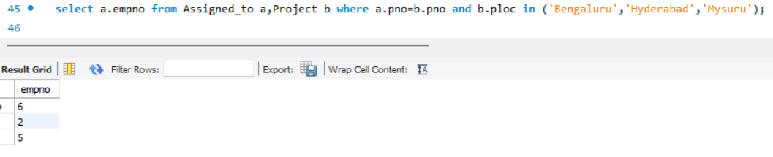

1. **Get employee no of those employees who didn’t receive incentives.**

select empno from Employee where empno not in(select Incentives.empno from Employee cross join Incentives on Employee.empno=Incentives.empno);

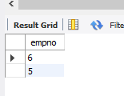

1. **Write a SQL query to find the employees name, number, dept, job_role, department location and project location who are working for a project location same as his/her department location.**

select a.ploc,b.job_role,c.empno,c.ename,d.dloc,d.dname from Project a,Assigned_tob,Employeec,Dept d where a.pno=b.pno and b.empno=c.empno and c.deptno=d.deptno and a.ploc=d.dloc;

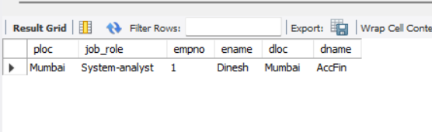

**Spot Query:**

select a.ename,b.dname,c.job_role from Employee a,Dept b,Assigned_to c,Incentives d where b.deptno=a.deptno and a.empno=c.empno and c.empno=d.empno and d.incentive_amount=(select max(incentive_amount) from Incentives where incentive_date between '2012-01-01' and '2012-12-31');

